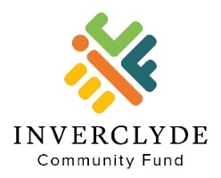

Inverclyde Windfarm Fund
Grant Application Form

To apply for a grant please complete this form and send it to us with:
- The governing document (constitution, memorandum & articles, or rules) of your organisation.
- The most recent accounts of your organisation or a recent bank statement if you are a new group.

- Tell us about your organisation
Organisation name
Address
Website
Facebook
Twitter
Contact for this application
Name
Position
Telephone / Mobile
Email
Aims and Activities of Your Organisation
What does your organisation do and who do you support?

Where did you hear about Inverclyde Community Fund? (Please X)
Word of Mouth
Direct Email
Inverclyde Community Fund Website
Social Media (Facebook/Twitter/LinkedIn)
CVS Inverclyde
Local Press
Previously received a grant from ICF
Other, (please detail below)

Organisation Bank Account Details
Name of Bank
Branch Address
Account Name |  | Postcode
Account No. |  | Sort Code

- Tell us about your project / activity
What would you like to do with the grant? Please describe your project or activity.
Who or what will benefit from your project or activity?
What will the grant pay for? Please provide an estimate of the costs.
What is the total cost of your project or activity? | £
How much grant are you requesting from us? | £
When will your project or activity start?

- Referee
Please provide the name and contact details of an independent referee who knows your organisation well and supports this application. The referee must not be connected to your organisation.
Name
Position & organisation
(if appropriate)
Address

Telephone / mobile
E-Mail
In what capacity does this referee know your organisation?

- Declaration
In signing below:
- I confirm that I have authorisation from this organisation to apply for a grant.
- I confirm that the referee is aware of and supports this application for a grant.
- I agree to complete an end of grant report when requested.
- I declare that I have not knowingly provided false or misleading information above.
- I’m happy to support promotion of the Inverclyde Community Fund should my application be successful.
Signature
Print Name
Position | Chair / Secretary / Treasurer / Trustee / Other
Date

- Sending Your Application

Please send the following documents by email to: apply@inverclydecommunityfund.org.
- Your completed application form in Word format. Please do not send the application form in PDF format
- The governing document (constitution, memorandum & articles, or rules) of your organisation.
- The most recent accounts of your organisation or a recent bank statement if you are a new group.

If you are unable to email your application and supporting documents, you can post or deliver them in person to:

Inverclyde Community Fund SCIO
c/o Inverclyde Community Hub
75-81 Cathcart Street
Greenock
PA15 1DE
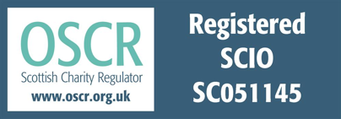
Tel: 01475 866140 or 07821 170746
Email enquiries: apply@inverclydecommunityfund.org

